PROGRAMME: BSSE/BSCS/BIT
YEAR/SEM: YEAR 2 SEM 1
COURSE CODE: COURSE CODE COMES HERE
PROBLEM NAME: COMPLETE NAME OF TASK

STUDENT DETAILS:
NAME OF STUDENT | Mulumeoderhwa Bahati Dieudonne
REG NUMBER | 25/1512/BSCS-S

Table of Contents
Contents | Page
QUESTION 1: Variable Types | 3
Section 1: Logic Building & Programming | 3
1.1 Lines of Code & Explanations | 3
1.2 IntelliJ Screenshot | 4
Section 2: Output | 5
2.1 Output and Caption Descriptions | 5
2.2 Output Explanation | 6
Section 3: Key Takeaways | 6
3.1 Key Takeaways | 6
QUESTION 2: Data Conversion | 7
Section 1: Logic Building & Programming | 7
1.1 Lines of Code & Explanations | 7
1.2 IntelliJ Screenshots | 9
Section 2: Output | 11
2.1 Output and Caption Descriptions | 11
2.2 Output Explanation | 12
Section 3: Key Takeaways | 12
3.1 Key Takeaways | 12

List of Figures
Figure 1:Class Main showing project structure 4

Section 1
Logic Building & Programming
Lines of code & explanations
Line Number | Explanation
#1 | Declares a class named Variable.
#3 | Declares an instance variable and initializes it to 10.
#4 | Declares a static variable and initializes it to 20.
#6 | Declares the displayVariables method.
#7 | Declares a local variable and initializes it to 30.
#9 | Prints the value of the local variable.
#10 | Prints the value of the instance variable.
#11 | Prints the value of the static variable.
#14 | The main method is the entry point of the program.
#15 | Creates an object of the Variable class.
#16 | Calls the displayVariables method using the object.

Detailed Screenshots and caption descriptions
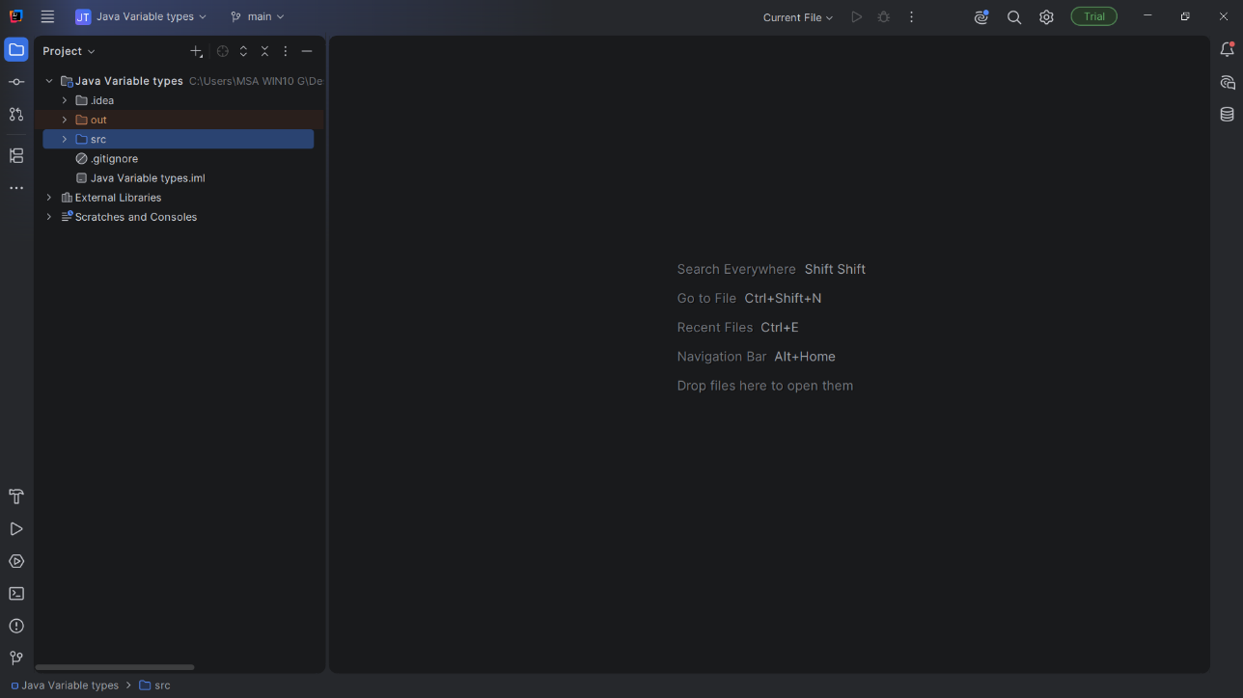
Figure 1:Class Main showing project structure

Output and caption descriptions
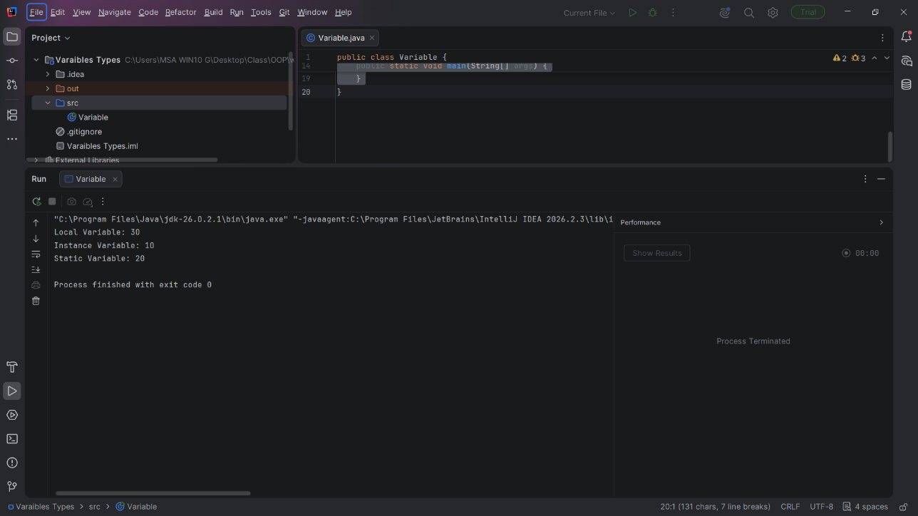
Figure 2: Output after running the program

Output Explanation
When the program runs, an object of the Variable class is created. The displayVariables() method is then called. The local variable has a value of 30, the instance variable has a value of 10, and the static variable has a value of 20. The program displays all three values in the console.

Section 2
Version Control
Repository Overview
Repository Name
Repository URL
Branches

Commit #1 On Branch #1
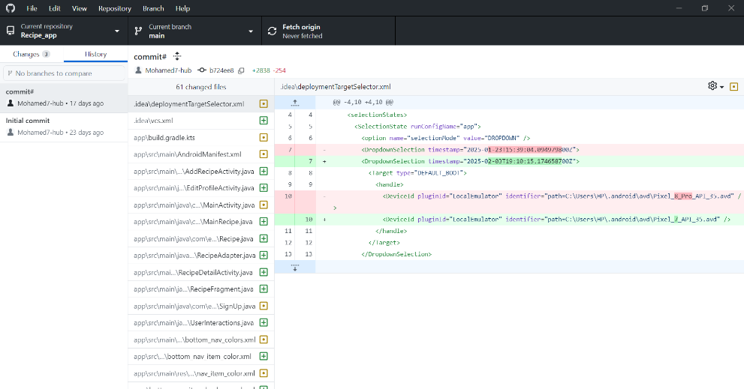
Figure 3: Commit 1 on Branch 1

Commit Summary
Commit Name
Commit ID
Commit Description
Branch Affected

Section 3
What Have You Learned From The Task?

Skill Set | Description

